ITCS216: Fundamentals of Database Systems (1/2025)

Faculty of Information and Communication Technology
In-class Exercise 06: Mapping EERD to Relational Schema

Objectives:
- Transform the given Entity Relationship Diagram to a relational model step by step
Instructions:
- From the given ER diagram, use 8-step transformation to create a relational model.
Note: you must show the step-by-step transformation
- Draw the final relational model

Given the following EER diagram, use 8-step transformation to create a relational model, including
- Transform regular entities including simple and composite attributes
- Transform weak entities
- Transform 1:1 relationship
- Transform 1:M relationship
- Transform M:M relationship
- Transform multivalued attributes
- Transform N-ary relationship
- Transform specialization or generalization
Note: If some steps are not applicable in the ERD, i.e., no that entities, attributes, or relationship, etc., please clearly specify “Not applicable” in the step.

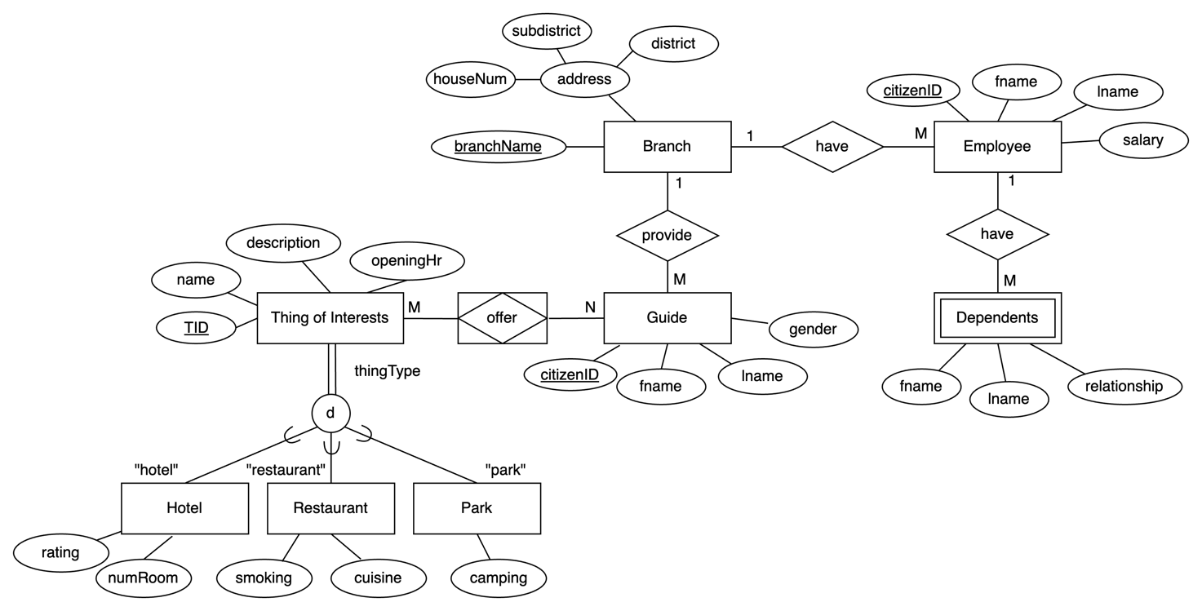
Before starting to draw the final relational model, please complete this table below

Step | Found in EERD?  (Yes/No) | Which entities are involved? What changes?
1 Regular | Yes | Employee, Dependents, Branch, Guide, Thing of Interests, Hotel, Restaurant, and Park.  The attribute of Branch, address got excluded.
2 Weak | Yes | Dependents  The citizenID from Employee assigned to Dependents
3 1:1 | Yes | Total of Interests  All of the subclass of Total of Interest will share the same FK from its superclass
4 1:M | Yes | Branch get the EcitizenID from Employee  Guid get the branchName from Branch  Dependents get FK from Employee
5 M:N | Yes | Offer get TID as PK and FK  Offer get GcitizenID as PK and FK
6 Multivalued | No
7 N-ary | No
8 Specialization | Yes | Total of Interests has three subclass, and both of them share the same PK from its superclass.

- Transform regular entities including simple and composite attributes

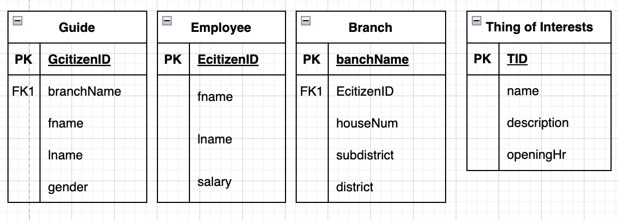

- Transform weak entities
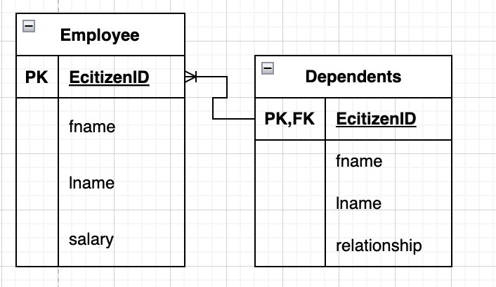

- Transform 1:1 relationship
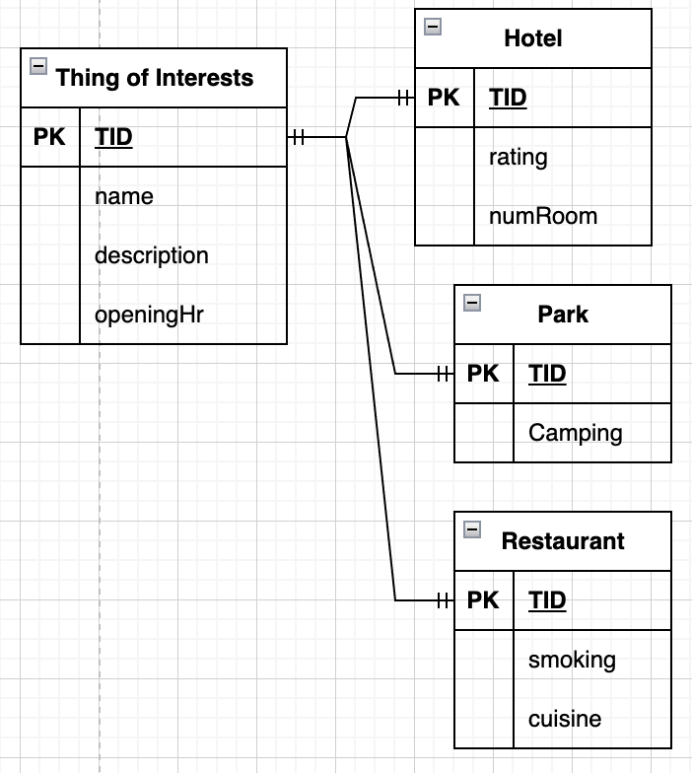

- Transform 1:M relationship

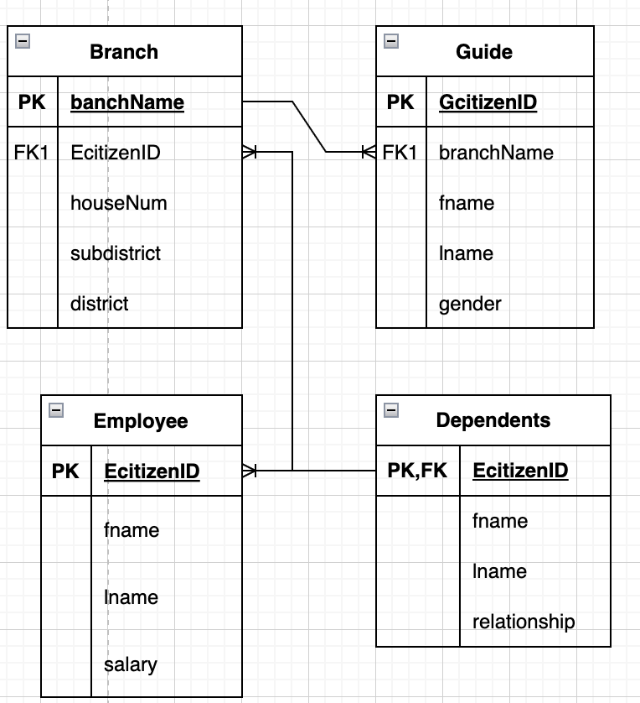

- Transform M:M relationship

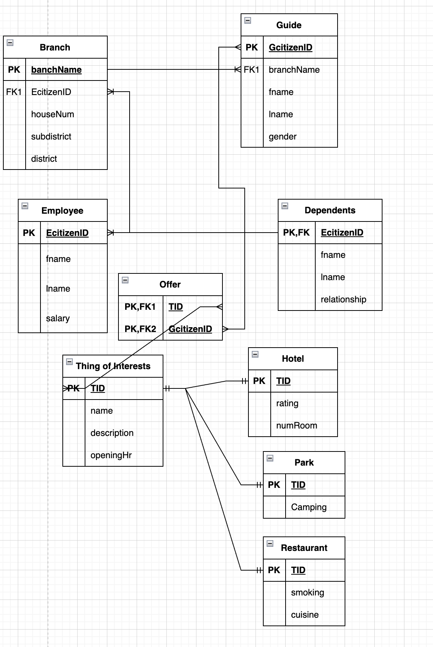

- Transform multivalued attributes

No multivalued attributes in the graph

- Transform N-ary relationship

No N-ary relationship in the graph

- Transform specialization or generalization
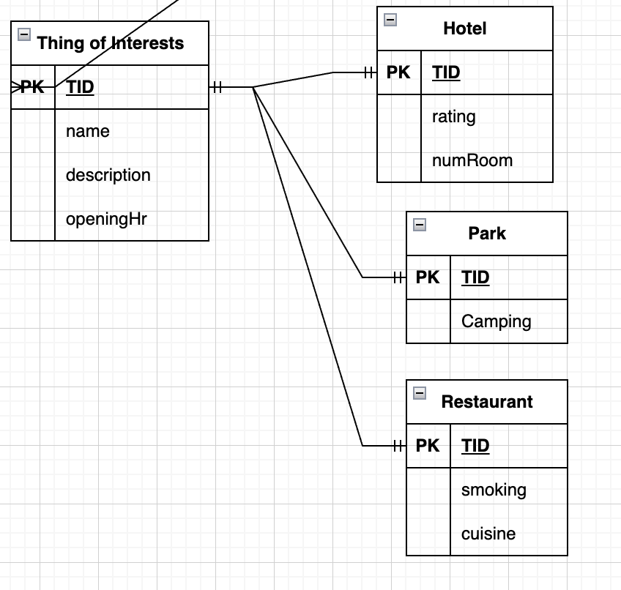
Final Relational Model

